Project Design Phase-II
AI FAQ Assistant Data Flow Diagrams and User Stories

Date | 28 September 2026
Team ID | 6ab218e687602313e82c53ab
Project Name | AI FAQ Assistant
Maximum Marks | 4 Marks

Data Flow Diagrams:
A Data Flow Diagram (DFD) is a traditional visual representation of the information flows within a system. A neat and clear DFD can depict the right amount of the system requirement graphically. It shows how data enters and leaves the system, what changes the information, and where data is stored.
Example: DFD Level 0 (Industry Standard)
AI FAQ Assistant Data Flow Diagrams(Simplified)
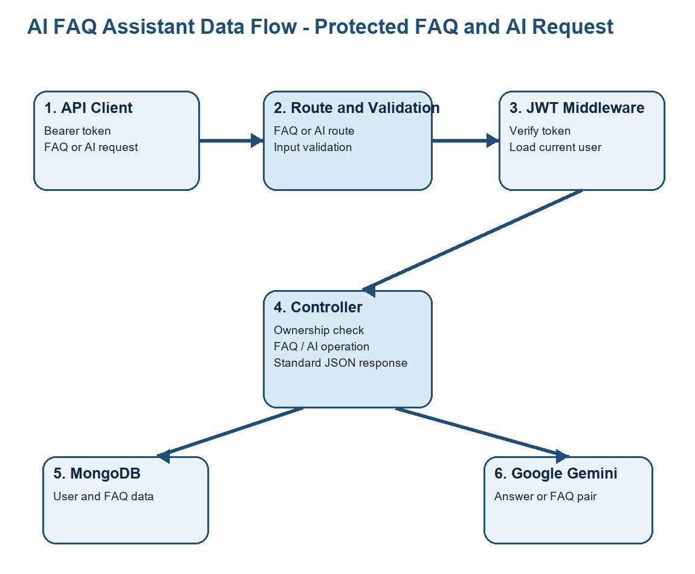

User Stories
The user stories below describe the core public and authenticated API interactions.
User Type | Functional Requirement (Epic) | User Story Number | User Story / Task | Acceptance criteria | Priority | Release
Public user | FAQ discovery | USN-1 | As a public user, I can view all FAQs so I can read published support information. | GET /api/faqs returns FAQs with a success status and count. | High | Sprint-1
Public user | FAQ search | USN-2 | As a public user, I can search FAQs by a keyword so I can find relevant answers quickly. | GET /api/faqs/search?q=term returns matching question, answer, or category content. | High | Sprint-2
New user | Registration | USN-3 | As a new user, I can register with name, email, and password so I can obtain an account. | Valid registration returns user data and a JWT; duplicate emails are rejected. | High | Sprint-1
Registered user | Login | USN-4 | As a registered user, I can log in with my email and password so I can use protected routes. | Valid credentials return a JWT; invalid credentials return 401. | High | Sprint-1
Authenticated user | Profile access | USN-5 | As an authenticated user, I can access my profile so I can confirm my account details. | GET /api/auth/profile returns the current user without the password when a valid token is supplied. | Medium | Sprint-1
Authenticated user | FAQ creation | USN-6 | As an authenticated user, I can create an FAQ so I can add approved support content. | A valid question, answer, and category create a FAQ owned by the current user. | High | Sprint-1
FAQ creator | FAQ ownership | USN-7 | As an FAQ creator, I can update or delete my own FAQ so I can keep content accurate. | The creator can change or delete the FAQ; another user receives 403. | High | Sprint-2
Authenticated user | AI answer generation | USN-8 | As an authenticated user, I can request an AI answer to help draft a response. | A valid question returns a Gemini answer when the API key is configured. | Medium | Sprint-2
Authenticated user | AI FAQ generation | USN-9 | As an authenticated user, I can generate a structured FAQ pair from a topic. | A valid topic returns a question and answer pair in the API response. | Medium | Sprint-2

